**CNN-LSTM:** (30 epoch, Previous 5 years of data from now)

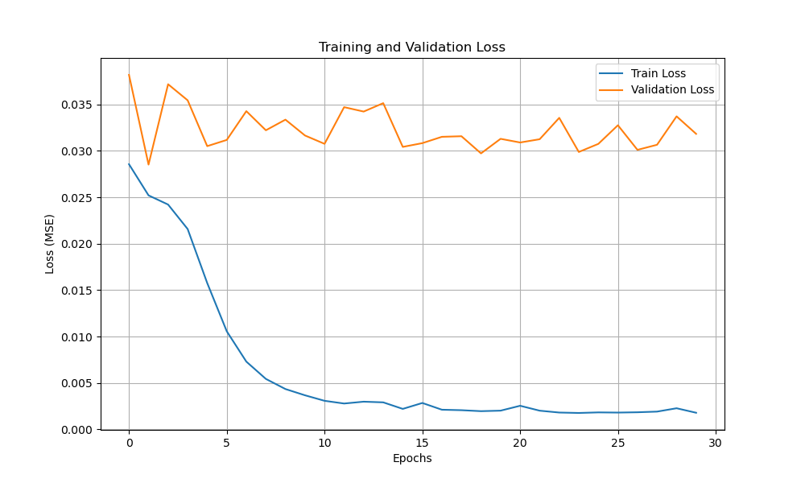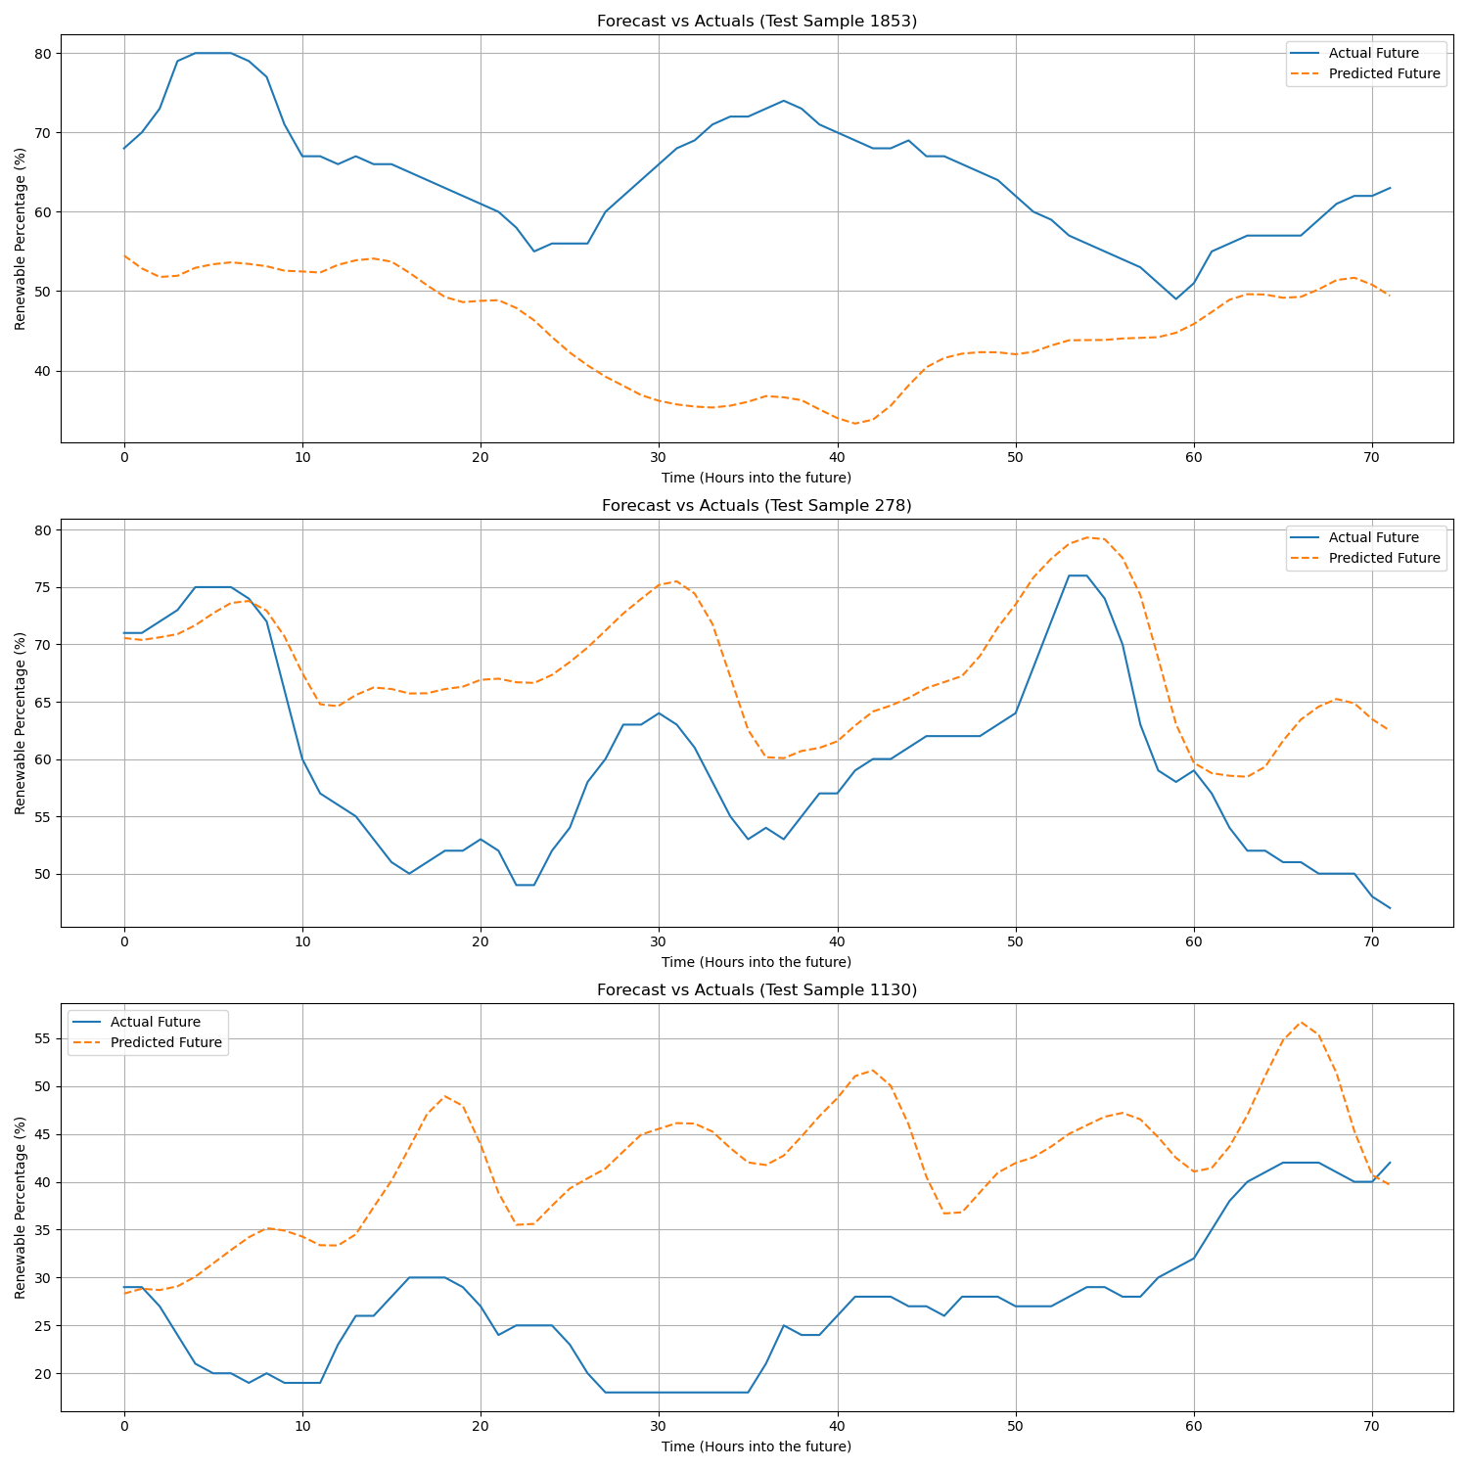

• **Overall:** The model is learning the patterns of the training data very well, but it is overfitting, which limits its ability to accurately predict unseen data.

• **Error Metrics:** The model's predictions on the test set are off by an average of 12.2 percentage points (MAE), with larger errors being common (RMSE of 15.4).

• **Loss Plot:** The training loss (blue line) decreases consistently, while the validation loss (orange line) flattens out early, showing a significant and growing gap that indicates overfitting.

• **Forecast Plots:** The model successfully captures the general shape of the future energy trends but often misses the correct timing and magnitude of the peaks and valleys.

**CycleLSTM: (500 epochs)**

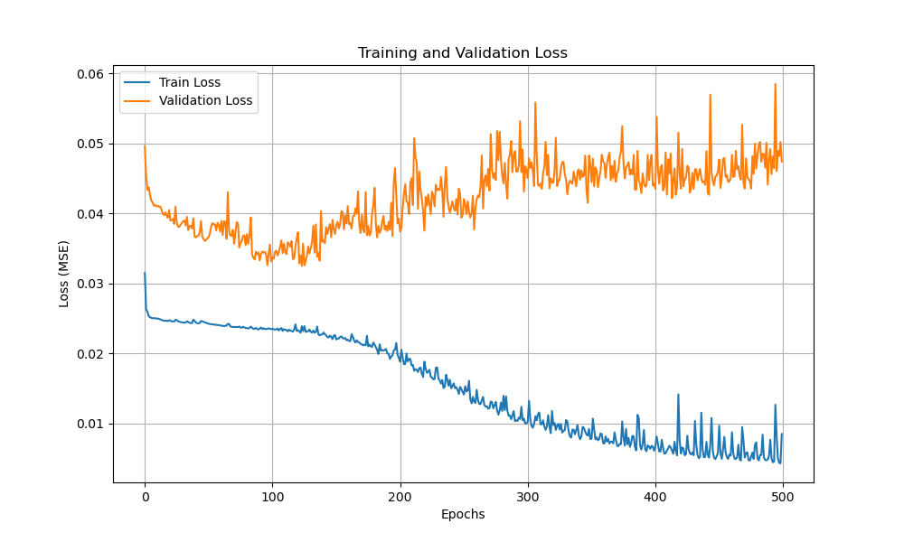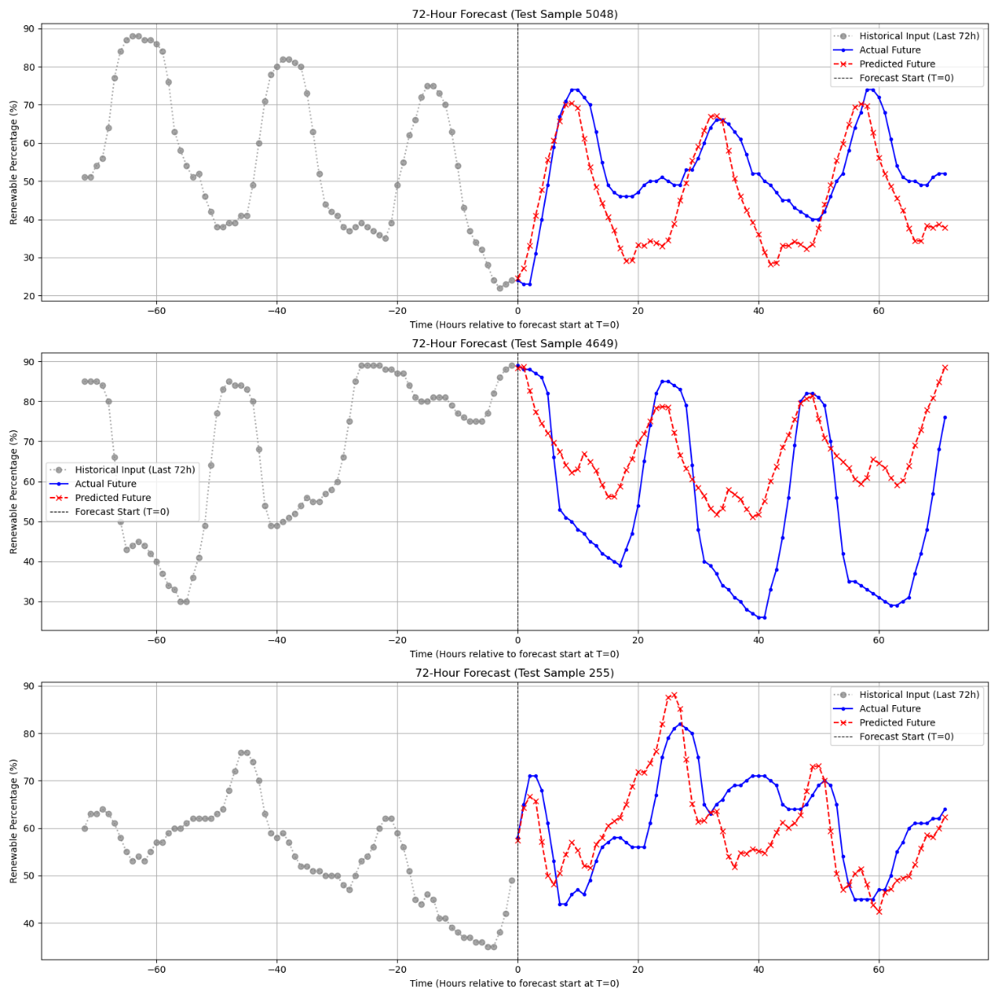

• **Error Metrics:** The Mean Absolute Error is 13.0555, and the Root Mean Squared Error is 16.4731, indicating a high error rate with some significantly incorrect predictions.

• **Loss Plot:** The training loss consistently decreases while the validation loss increases after ~100 epochs, which is a clear sign of overfitting.

• **Forecast Plots:** The model correctly predicts the general shape and daily rhythm of the energy forecast but fails on precise timing and magnitude.

FIX?:  
  
• An EarlyStopping callback was added to automatically stop training when performance on unseen data no longer improves.

• The LSTM hidden_size was reduced from 64 to 32 to decrease the model's complexity.

• The dropout rate was increased from 0.2 to 0.4 to add more regularization.

**CycleLSTM V2: (Early stopping)**

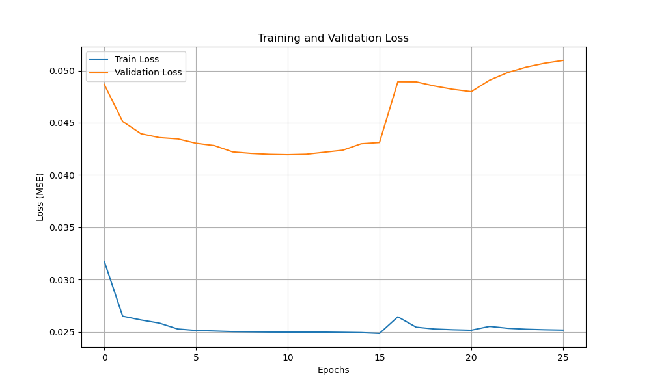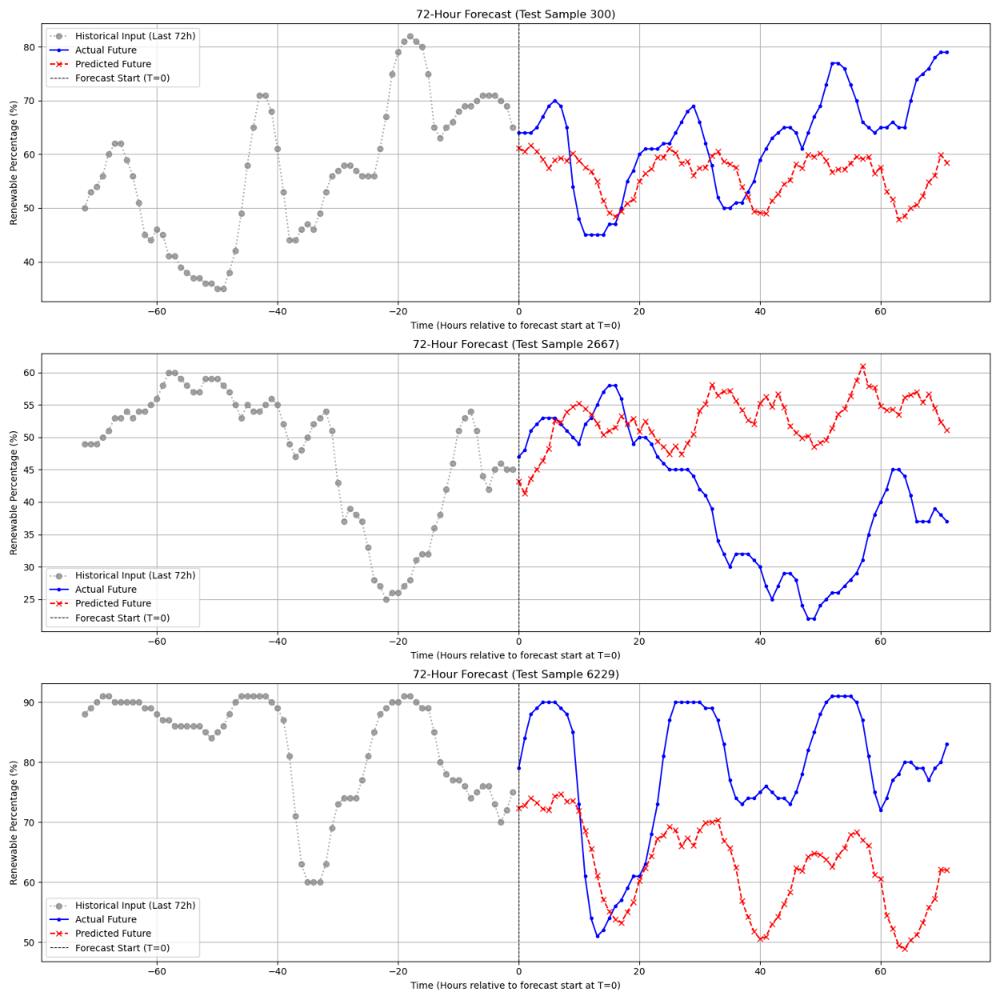

• **Overall:** The changes successfully reduced overfitting and slightly improved the model's predictive accuracy.

• **Error Metrics:** The MAE (12.7) and RMSE (15.4) show a minor improvement, meaning the model is now performing slightly better on unseen data.

• **Loss Plot:** Early stopping worked as intended, halting the training around epoch 25 when the validation loss stopped improving, which prevented severe overfitting.

• **Forecast Plots:** The model continues to capture the daily cyclical patterns well but still has difficulty predicting the exact magnitude of the peaks and troughs.